1. IAM settings are region specific or NOT

1. No, IAM is not a region specific because its global.

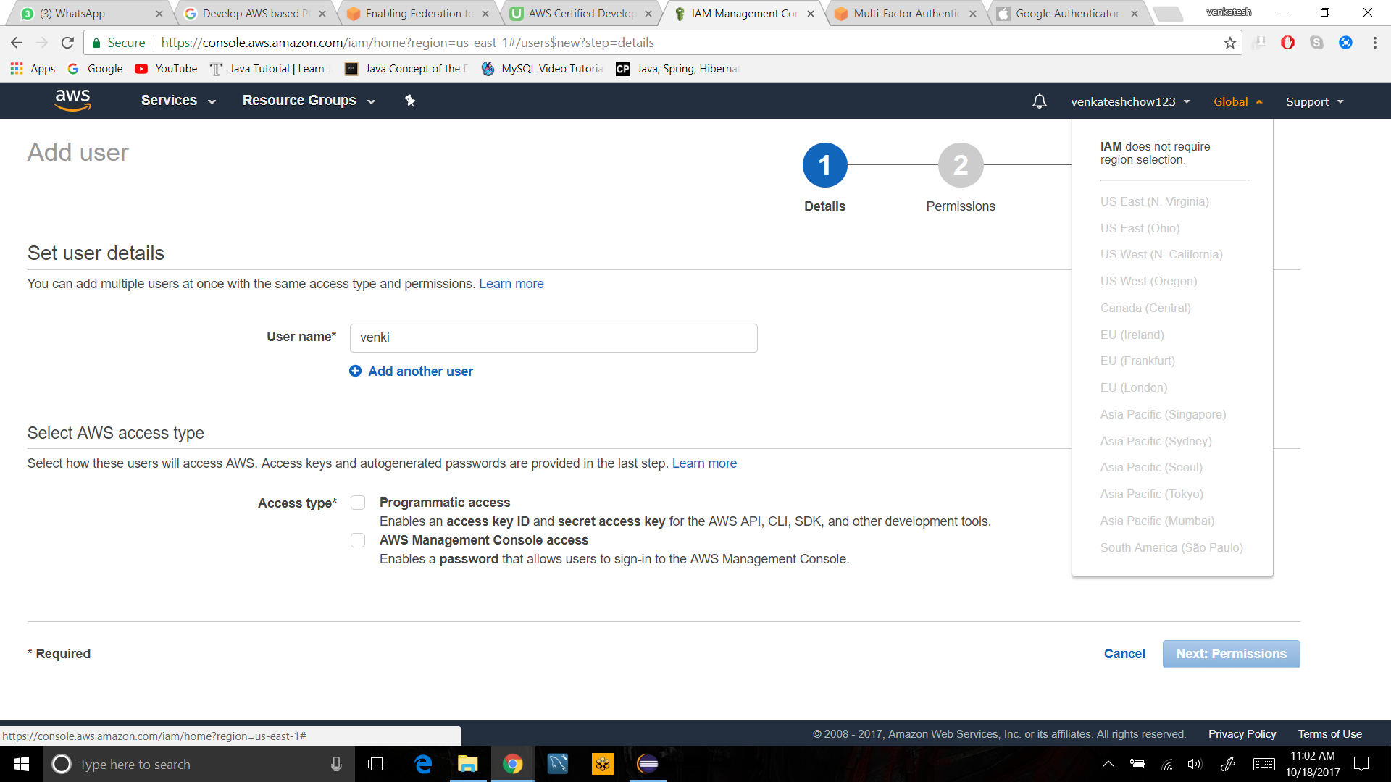

2. By default users have no permissions when first added

1. No, users doesn't have any permissions when added

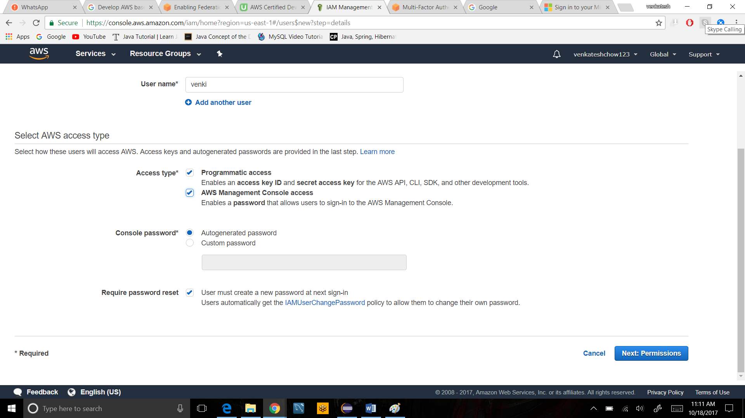

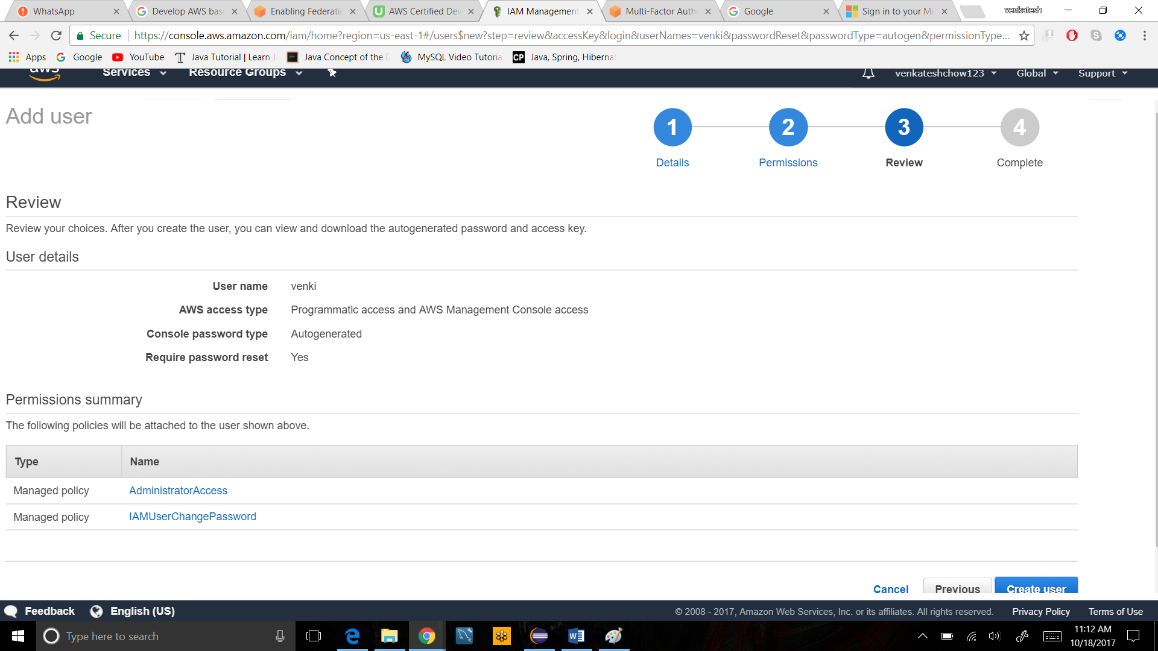

3. Active Directory Federation (AD) Can authenticate to AWS with AD using SAML

 YES   Active Directory Federation (AD) Can authenticate to AWS with AD using SAML

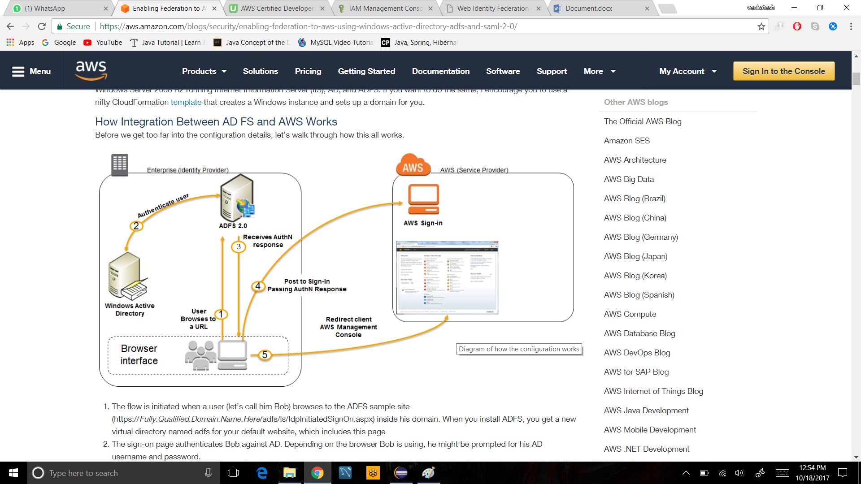

4. Web Identity Federation to AWS via Facebook or any other social sites

1. YES, by Web Identity Federation to AWS  we can access to any social  sites

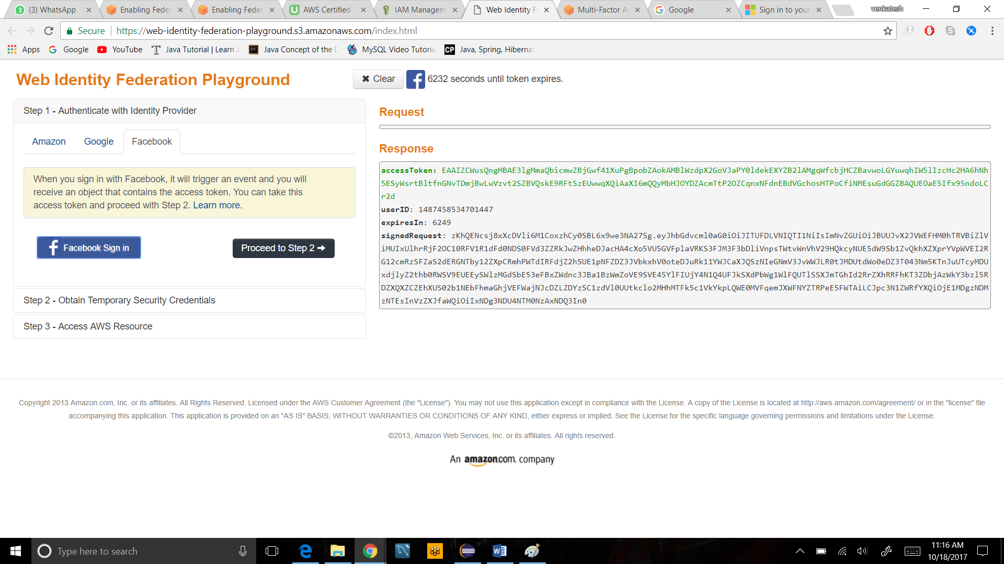

5. AssumeRoleWithWebIdentity API call used to obtain temporary security credentials when authenticating using Web Identity Federation?

1. We get the temporary security credentials by calling the  Assume Role With WebIdentity  then we can access AWS resources like list bucket or get object

